Model Development Phase

Date | 15 February 2026
Team ID | LTVIP2026TMIDS66291
Project Title | Civil Engineering Insight Studio
Maximum Marks | 10 Marks

Initial Model Training Code, Model Validation and Evaluation Report
In this project, no custom model training is performed. Instead, a pre-trained generative AI model is integrated and used for material generation. The focus of this phase is on model selection, configuration, prompt design, and output evaluation, rather than training from scratch.
Initial Model Training Code:
Model Selection and Initialization
The Gemini Flash Lite (models/gemini-flash-lite-latest) model is selected due to its lightweight architecture, faster response time, and suitability for real-time Image generation tasks.
The model is initialized using the Google Generative AI API. Configuration parameters such as temperature, top-p, top-k, and maximum output tokens are defined to control creativity, response quality, and output length.
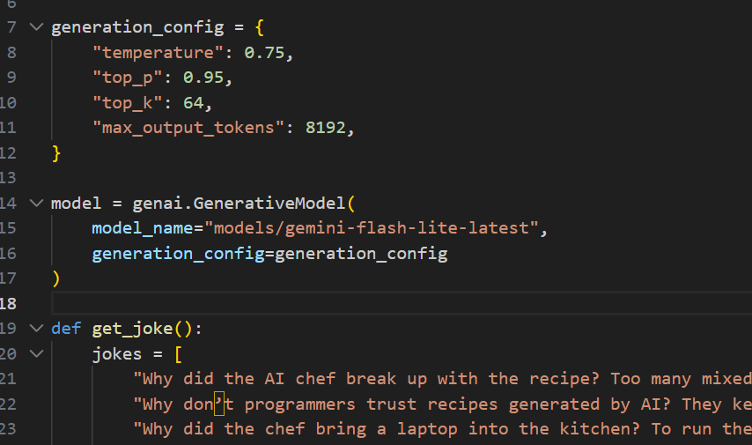

Model Validation and Evaluation Report:
Model | Summary | Training and Validation Performance Metrics
Gemini Flash Lite | Pre-trained Image model optimized for fast data generation | Relevance of generated content, coherence, clarity, and response time

